From New York: I-95 South to Exit I-395 – Baltimore City. Turn right onto Pratt Street. Turn left onto President Street. President Street turns into I-83 North. Exit 10-A Northern Parkway East. Turn right at the first light onto Falls Road. Turn right at the first light into the Village of Cross Keys. Turn left after the gatehouse, right at the stop sign and follow the gray signs toward the Radisson main entrance. Guest parking is available in the first parking lot. Take the elevator “L” (lobby) level.
From
Washington DC: I-95 North to Exit I-395 – Baltimore City. Turn right onto Pratt Street. Turn left onto President Street. President Street turns into I-83 North. Exit 10-A Northern Parkway East. Turn right at the first light onto Falls Road. Turn right into the Village of Cross Keys. Turn left after the gatehouse, right at the stop sign and follow the gray signs toward the Radisson main entrance. Guest parking is available in the first parking lot. Take the elevator “L” (lobby) level.

From York, PA: I-83 South to Exit 10-A Northern Parkway East. Turn right at the first light onto Falls Road. Turn right at the first light into the Village of Cross Keys. Turn left after the gatehouse, right at the stop sign and follow the gray signs toward the Radisson main entrance. Guest parking is available in the first parking lot. Take the elevator “L” (lobby) level.

From Annapolis: I-50 West to I-97 North. Exit I-695 North (Towson). Exit #23 onto 83 South. Exit 10-A Northern Parkway East. Turn right at the first light onto Falls Road. Turn right into the Village of Cross Keys. Turn left after the gatehouse, right at the stop sign and follow the gray signs toward the Radisson main entrance. Guest parking is available in the first parking lot. Take the elevator “L” (lobby) level.

From Columbia: Route 29 North to exit for I-70 West. Take I-695 North to Exit #23 onto 83 South. Exit 10-A Northern Parkway East. Turn right at the first light onto Falls Road. Turn right into the Village of Cross Keys. Turn left after the gatehouse, right at the stop sign and follow the gray signs toward the Radisson main entrance. Guest parking is available in the first parking lot. Take the elevator “L” (lobby) level.

From BWI Airport: I-295 North to Baltimore City. Turn right onto Pratt Street. Turn left onto President Street. President Street turns into I-83 North. Exit 10-A Northern Parkway East. Turn right at the first light onto Falls Road. Turn right at the first light into the Village of Cross Keys. Turn left after the gatehouse, right at the stop sign and follow the gray signs toward the Radisson main entrance. Guest parking is available in the first parking lot. Take the elevator “L” (lobby) level.

From
Dulles Airport: Exit airport onto I-495 East – Baltimore. Follow I-495 East approximately 20 miles. Exit I-95 North. Exit I-395 North – Baltimore City. Turn right onto Pratt Street. Turn left onto President Street. President Street turns into I-83 North. Exit 10-A Northern Parkway East. Turn right at the first light onto Falls Road. Turn right at the first light into the Village of Cross Keys. Turn left after the gatehouse, right at the stop sign and follow the gray signs toward the Radisson main entrance. Guest parking is available in the first parking lot. Take the elevator “L” (lobby) level.

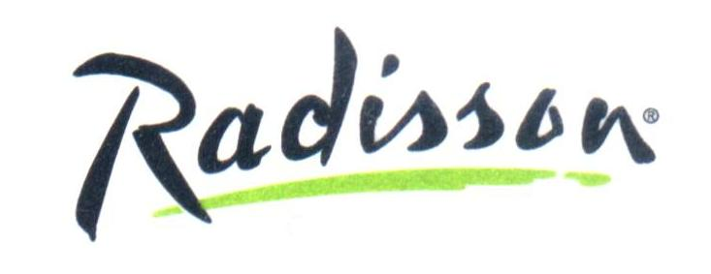
Radisson Hotel at Cross Keys
5100 Falls Road • Baltimore, Maryland 21210
Telephone: 410-532-6900 • Fax: 410-532-8602
www.radisson.com

